Sacred Heart, Howden and St Joseph & St Thomas, Goole

  - 1 Buttfield Road, Howden. Telephone: 01430 430245 Parish website: http://www.sacredheartstjoseph.org.uk
3rd Sunday in Ordinary Time/Year B Sunday 21st January 2018
_______________________________________________________________

Date | Time | Place | Service/Event | Intentions
Sat 21st Dec | 5.30pm | St Joseph’s | Vigil Mass | People of the Parish
Sun 2nd Jan | 9.30am | Sacred Heart | Mass | RIP Maureen R Hall (10th Anniversary on 22nd January)
 | 11.00am | St Joseph’s | Mass | Nov Dead List: RIP Hodgson family, Goodison family
Mon 22nd Jan | No Mass
Tues 23rd Jan | 9.15am | Sacred Heart | Octave of Prayer for Christian Unity: Morning Prayer
Tues 23rd Jan | 10.00am | Sacred Heart | Mass | Churches of the Howdenshire Villages
Wed 24th Jan | 10.00am | St Joseph’s | Mass | Methodist/URC Churches, Revive Church, Salvation Army - Goole, St John’s - Goole
Thur 25th Jan | 10.00am | Sacred Heart | Mass | Howden Minster & Howden Methodist Church
Thur 25th Jan | 10.30am-10.50am | Sacred Heart | Confessions
Thur 25th Jan | 11.30am | Reflection & Prayer at Howden Methodist Church:
Thur 25th Jan | 12.00am | Soup Lunch at Howden Methodist Church |  | OCTAVE ENDS
Fri 26th Jan | 10.00am | St Joseph’s | Mass | RIP Harry Tansley (6th Anniversary on 21st Jan)
Fri 26th Jan | 10.30am-10.50am | St Joseph’s | Confessions
Sat 27th Jan | 5.30pm | St Joseph’s | Vigil Mass | RIP Geoffrey Rhodes (6th Anniversary on 20th Jan)
Sun 21st Jan | 9.30am | Sacred Heart | Mass | People of the Parish
 | 11.00am | St Joseph’s | Mass | RIP Francis Sykes (LD)

The funeral of the late PATRICIA ANN MILLER will take place at St Joseph’s, Goole, at 10.00am on Tuesday 30th January. For this reason there will be no morning Mass at Sacred Heart that day.

POLISH MASS is offered on the first Saturday of each month at Goole. The next Polish Mass will be on Saturday 3rd February 2018 at 8pm.
MASA POLSKA jest oferowana w pierwszą sobotę każdego miesiąca w Goole. Następna polska msza odbędzie się w sobotę 3 lutego 2018 o 20.00.
Fr Wlodimierz Pajak, 117 Buckingham Street, Scunthorpe. Tel: 01724 855698

SICK & HOUSEBOUND - PLEASE PRAY FOR THEM
Damian Ainscough, Anna Barszcz, Margaret Brodigan, Jean de Bosch, Patience Dare, Carol Dent, Kathleen Evans, Anne Evans, Anne Hayward, Dorothy Kershaw, Anthony Margrave, Joan Marshall, Alma McHugh, Bernard Rook, Michael Ryan, Timmy Ryan, Margaret Scott, Pat Sullivan, Kevin and Catherine Thornton, Lynne Walker and all those who would like to remain anonymous.

Sacred Heart Christmas Hamper Draw raised £304. Total church fundraising now stands at £25,996.45

DONATIONS TO REFURBISHMENT FUND
Cheque donations can be made payable to ‘The Sacred Heart Refurbishment Fund.’ Thank you.

DON’T FORGET to bring food items to the back of St Joseph’s Church and Sacred Heart church for the food bank at Trinity Methodist Church, Goole, and woolly hats for the Apostleship of the Sea.

HOLY COMMUNION FOR THE SICK AND HOUSEBOUND
The letter of St James, Chapter 5, verse 14: “Is any among you sick? Let him call for the elders of the church, and let them pray over him, anointing him with oil in the name of the Lord.”
If you or anyone you know is ill, either in hospital or at home, and would like to receive the Church’s ministry in anointing and Holy Communion, please let Fr Nigel know and he will come and visit you/your family and friends.
St. Joseph’s Readers December/Jan
Sat 20th Jan | Mr K Flynn | Sun 21st Jan | Mrs P Sykes
Sat 27th Jan | Mrs J Head | Sun 28th Jan | Mrs R Gervais

Do you support Catholic schools and the right of parents to send their children to them? Then we need you to make your views known. The Prime Minister has acknowledged that this policy discriminates against Catholics and had promised previously to abandon it. Now the government may decide to keep this discriminatory policy in place instead of removing it. We need you to tell the Government not to discriminate against Catholics and to remove the admission cap on new faith-based schools. Visit http://catholicnews.org.uk/education-cap or search for ‘Catholic Education’ in your search engine to write to the Government and urge them to drop their policy which bans new Catholic schools.

CLEANING TEAM C for Howden this

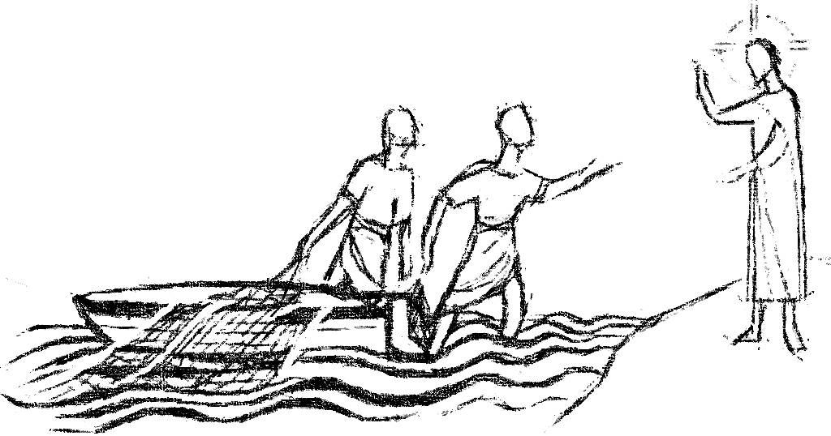

And at once they left their nets and followed him. Mark 1:18

REPARATION FOR FIRST RECONCILIATION (ST JOSEPH’S CHILDREN)
There will be 3 meetings which the enrolled children and a parent or carer must attend. These will be held on Wednesdays 21st and 28th of February and 7th March 2018 from 6-7p.m. at St Joseph’s Catholic Primary School, Kennedy Drive, Goole DN14 6HQ. I will confirm the date of the Reconciliation service as soon as possible. Catherine Murphy

PRZYGOTOWANIE DO PIERWSZEGO SAKRAMENT POKUTY I POJEDNANIA
Odbędą się 3 spotkania, w których uczestniczyć będą zapisane dzieci oraz rodzic lub opiekun. Spotkania odbędą się w środy 21 i 28 lutego oraz 7 marca 2018 r. W godzinach 18.00-19.00 w katolickiej szkole podstawowej św. Józefa,(St Joseph’s Catholic Primary School), adres szkoły: Kennedy Drive, Goole DN14 6HQ. Potwierdzę termin tak szybko, jak to możliwe.
Catherine Murphy
weekMEDJUGORJE IRISH CENTRE
Pilgrimages 2018: 7 nights B&B and Airport Shuttle Service from €279 per person. Any flight. Any time. Call us for further information. Tel. Jackie on 0203 239 9862 or email reservations@med-irishcentre.com
Website: www.med-irishcentre.com

